***Public Dissemination***

*INCOSE Challenge Solution*

***Automatic documentation via Modelio***

**Author:Dr. Imran Rafiq Quadri**

Version:

Status:Final Version

Publication:2012-08-30T10:23:34Z

Copyright:

**Modeliosoft**

21 Avenue Victor Hugo, 75016 Paris - FRANCE

Table of Figures

Please, select this field and press F9 to create/update the table of figures

Table of Tables

Please, select this field and press F9 to create/update the table of tables

Table of Contents

Please, select this field and press F9 to create/update the table of contents

# Introduction

This project details how we can carry out systems engineering with Modelio and describes the solution for the INCOSE 2012 TVC

# Use Cases

## Actors

| Actor | Description |
| --- | --- |
| External Environment |  |
| Media |  |
| General Public |  |
| National Weather Service |  |
| Civil Aviation Authority |  |
| Military Aviation Authority |  |
| Air/Rotorcraft Manufacturer |  |
| DOC |  |
| Firefighters |  |
| Firefighting Equipment |  |
| Firefighting Vehicles |  |
| Air/Rotorcrafts |  |

Table 1 Table of Actors

## Use Cases

| Use-Cases | Description |
| --- | --- |
| Negotiate Air/rotorcraft specifications |  |
| Communication and Coordination |  |
| Global Operations |  |
| Flight Routes/Plans |  |
| Resource Management |  |

Table 2 Table of Use Cases

### Use Case "Use case Diagram"

This Use case Diagram describes the different actors relating to the PERCC

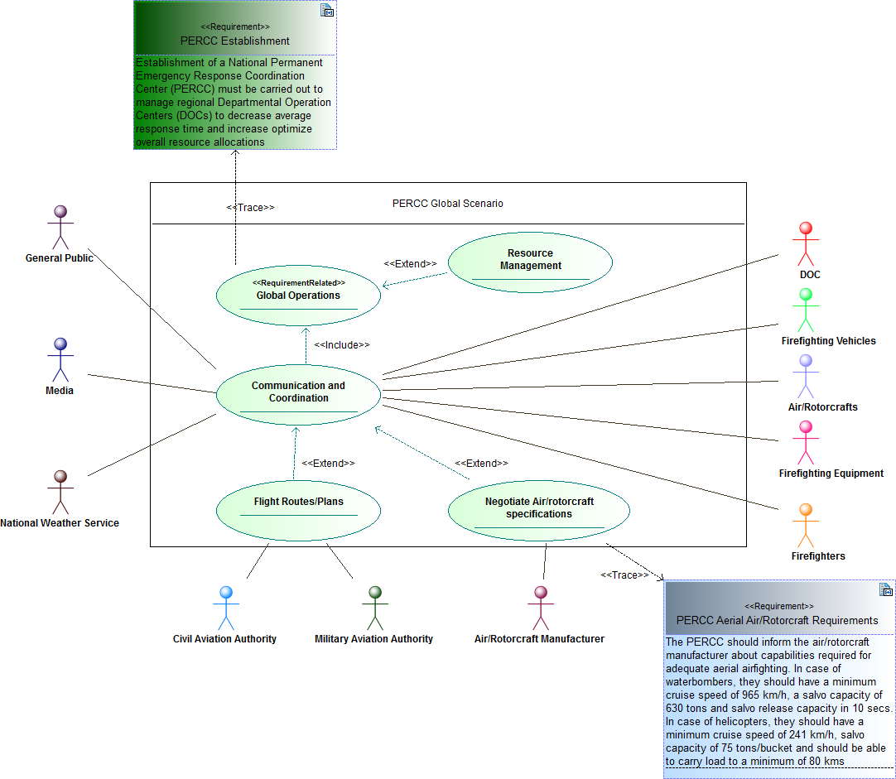

Figure 1 : Use case Diagram

# Package Index

|  |  |
| --- | --- |
| INCOSE_Challenge |  |
| Timeline |  |
| External Environment |  |
| PERCC Global Scenario |  |
| PERCC Structure |  |
| Internal Structure |  |
| Parametric |  |
| SI Derived Units Expressed In Base Units |  |
| SI Base Units |  |
| SI Derived Units With Special Names |  |
| Types |  |
| Value Types |  |
| Interfaces |  |
| INCOSE Challenge Solution |  |

# Package "INCOSE_Challenge"

This project details how we can carry out systems engineering with Modelio and describes the solution for the INCOSE 2012 TVC

| Name | Summary |
| --- | --- |
| Timeline |  |
| External Environment |  |
| PERCC Global Scenario |  |
| PERCC Structure |  |
| Types |  |
| INCOSE Challenge Solution |  |

Table 3 Owned Packages of Package "INCOSE_Challenge"

## Block "AnalystProperties"

from Package INCOSE_Challenge

Stereotypes: Model Component

## Block "SIDefinitions"

from Package INCOSE_Challenge

Stereotypes: Model Component

## Block "DCI"

from Package INCOSE_Challenge

Stereotypes: Model Component

## Block "DBMS software type"

from Package INCOSE_Challenge

Stereotypes: Model Component

# Package "Timeline"

from Package INCOSE_Challenge

| Name | Type | Description |
| --- | --- | --- |
| Timeline |  |  |

Table 4 Owned Activity of Package "Timeline"

Activity "Timeline"

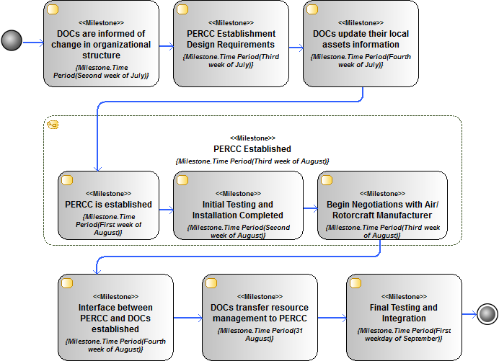

Figure 2 Timeline

This diagram shows the timeline

# Package "External Environment"

from Package INCOSE_Challenge

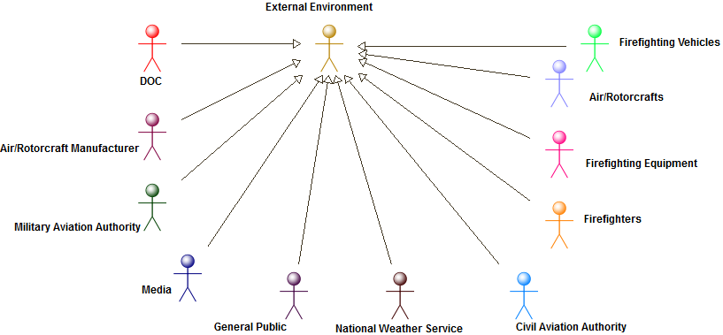

Figure 3 Actors

The hierarchical organization of the actors

# Package "PERCC Global Scenario"

from Package INCOSE_Challenge



Figure 4 Use case Diagram

This Use case Diagram describes the different actors relating to the PERCC

# Package "PERCC Structure"

from Package INCOSE_Challenge

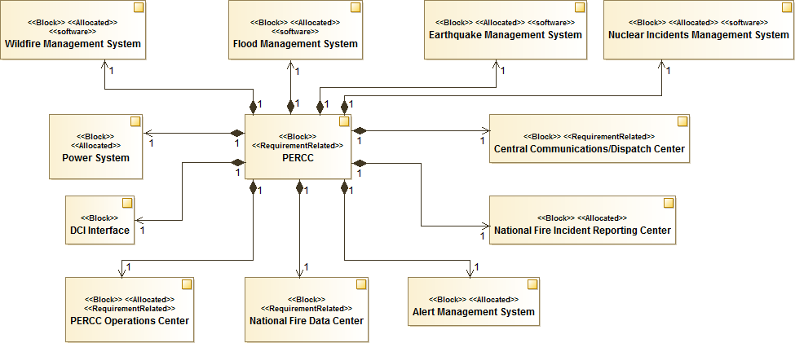

Figure 5 PERCC Block Diagram

This is the block diagram of the PERCC showcasing its overall structure

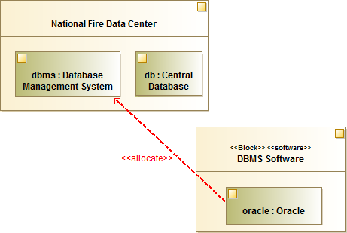

Figure 6 DBMS Software Allocation

This Allocation shows that different user defined or third party IPs can be used. Here the diagram shows the imported oracle block instance is allocated to the dbms instance of the Database Management System

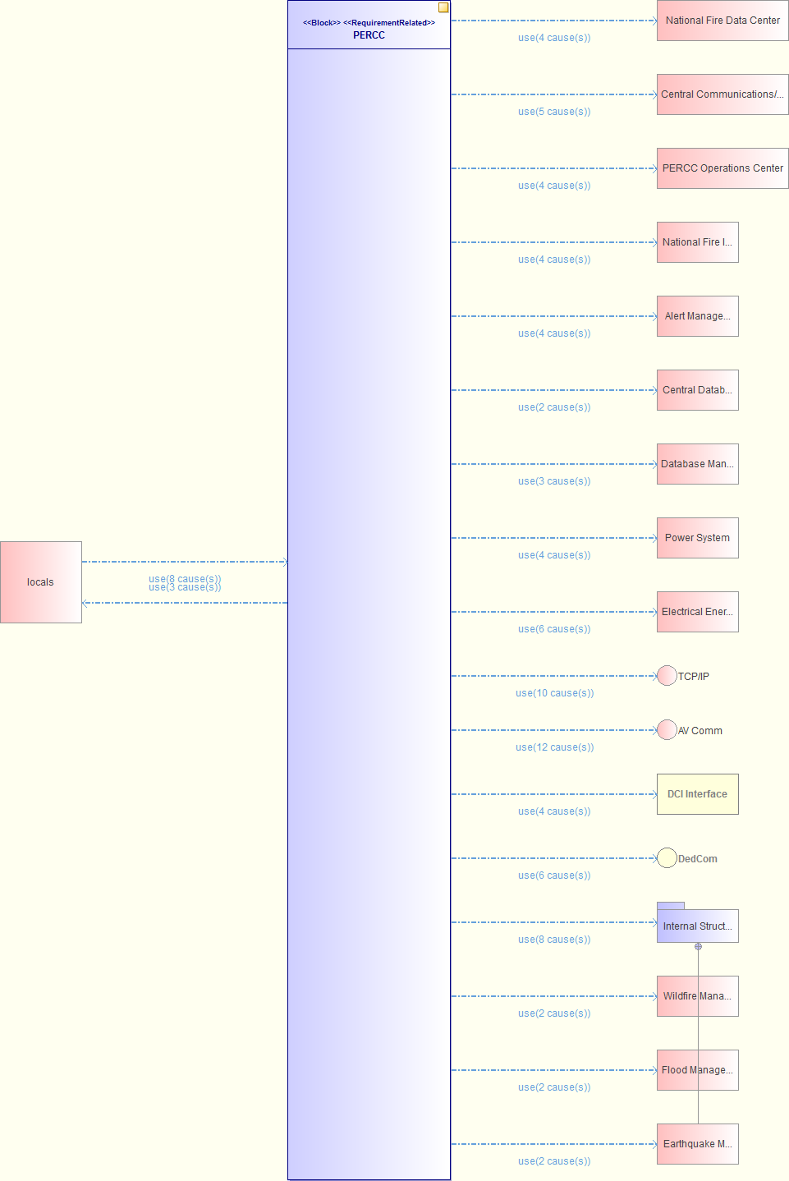

Figure 7 PERCC (dependency_autodiagram)

| Name | Summary |
| --- | --- |
| Internal Structure |  |

Table 5 Owned Packages of Package "PERCC Structure"

| Name | Summary |
| --- | --- |
| PERCC |  |

Table 6 Owned Block of Package "PERCC Structure"

## Block "PERCC"

from Package INCOSE_Challenge.PERCC Structure

Stereotypes: Block,RequirementRelated

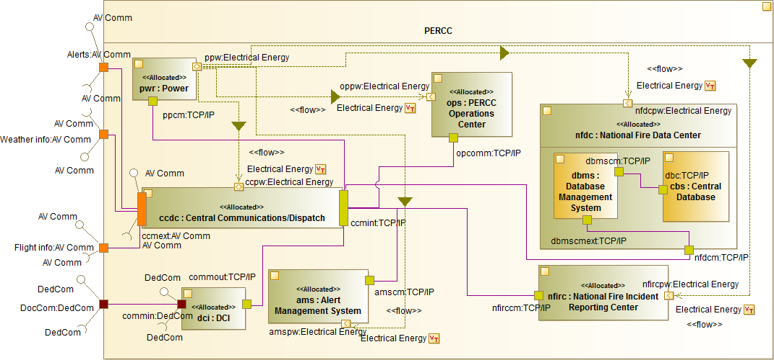

Figure 8 PERCC Internal Block Diagram

This Internal Block Diagram shows the internal composition of the PERCC

Activity "Global PERCC System Activity"

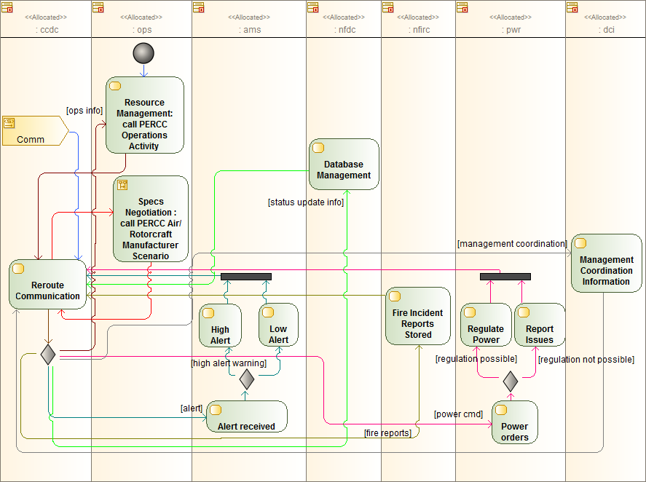

Figure 9 Global PERCC System Activity Diagram

The global activity showcasing the different operations of the PERCC components

Activity "Green Mode Activity"

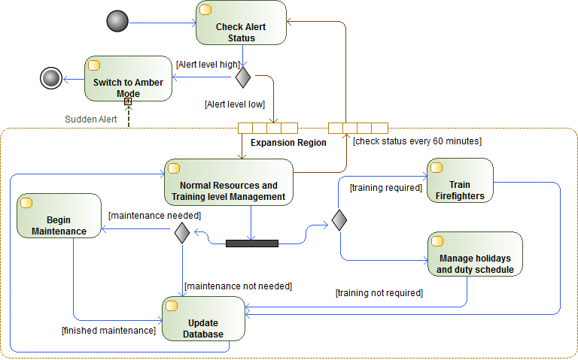

Figure 10 Green Mode Activity Diagram

This diagram shows the activity related to the green mode in case of a wildfire alert

Activity "Amber Mode Activity "

Activity "Red Mode Activity"

Interaction "PERCC Air/Rotorcraft Manufacturer Scenario"

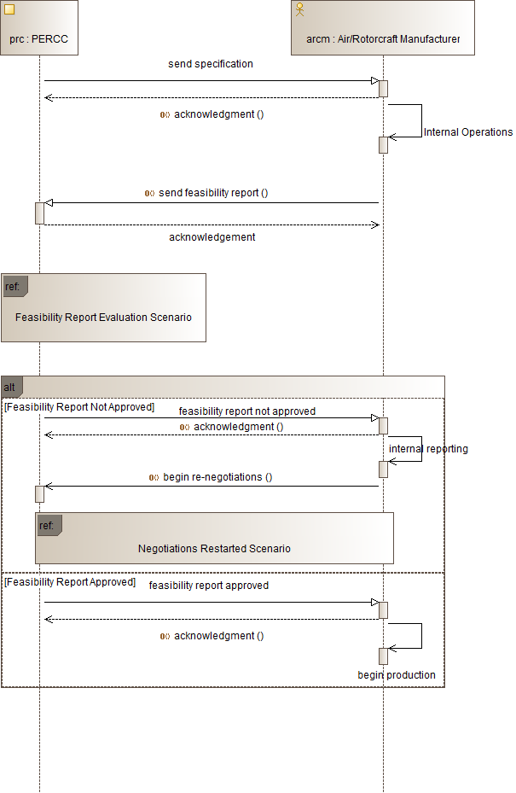

Figure 11 PERCC Air/Rotorcraft Manufacturer Scenario Sequence Diagram

The scenario between the PERCC and the Air/Rotorcraft manufacturer

Interaction "Feasibility Report Evaluation Scenario"

Interaction "Negotiations Restarted Scenario"

Activity "PERCC Operations Activity "

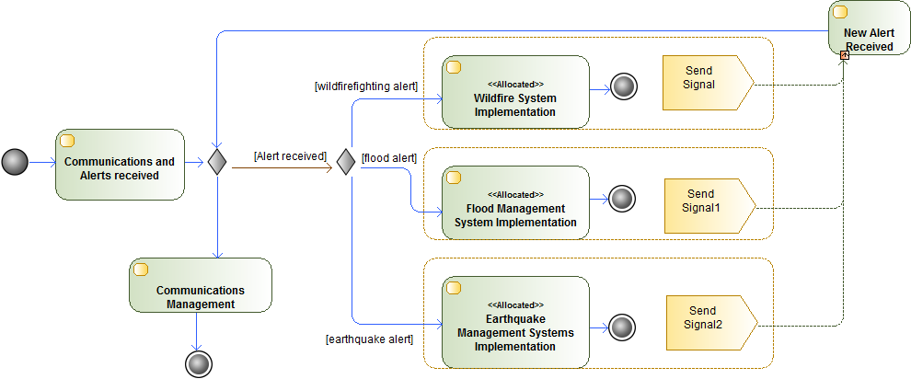

Figure 12 PERCC Operations Activity Diagram

This activity diagram shows the operations of the PERCC

| Name | Description |
| --- | --- |
| send feasibility report () |  |
| acknowledgment () |  |
| begin re-negotiations () |  |

Table 7 Operations of Block "PERCC"

| Name | Description |
| --- | --- |
| -> : [1..1] Power System |  |
| -> : [1..1] PERCC Operations Center |  |
| -> : [1..1] National Fire Data Center |  |
| -> : [1..1] Alert Management System |  |
| -> : [1..1] National Fire Incident Reporting Center |  |
| -> : [1..1] Central Communications/Dispatch Center |  |
| -> : [1..1] DCI Interface |  |
| -> : [1..1] Wildfire Management System |  |
| -> : [1..1] Flood Management System |  |
| -> : [1..1] Earthquake Management System |  |
| -> : [1..1] Nuclear Incidents Management System |  |

Table 8 Associations of Block "PERCC"

| Name | Requires | Provides |
| --- | --- | --- |
| Alerts | Interface AV Comm | Interface AV Comm |
| Flight info | Interface AV Comm | Interface AV Comm |
| Weather info | Interface AV Comm | Interface AV Comm |
| DocCom | Interface DedCom | Interface DedCom |

Table 9 Ports of Class "PERCC"

# Package "Internal Structure"

from Package INCOSE_Challenge.PERCC Structure

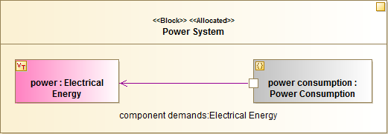

Figure 13 Power System Internal Block Diagram

The Power System Internal Block Diagram shows the power consumption constraint block property and the electrical energy value type

| Name | Summary |
| --- | --- |
| Parametric |  |

Table 10 Owned Packages of Package "Internal Structure"

| Name | Summary |
| --- | --- |
| National Fire Data Center |  |
| Alert Management System |  |
| National Fire Incident Reporting Center |  |
| PERCC Operations Center |  |
| Central Communications/Dispatch Center |  |
| Power System |  |
| Central Database |  |
| Database Management System |  |
| DBMS Software |  |
| Wildfire Management System |  |
| Flood Management System |  |
| Earthquake Management System |  |
| Nuclear Incidents Management System |  |

Table 11 Owned Block of Package "Internal Structure"

## Block "National Fire Data Center"

from Package INCOSE_Challenge.PERCC Structure.Internal Structure

Stereotypes: Block,RequirementRelated

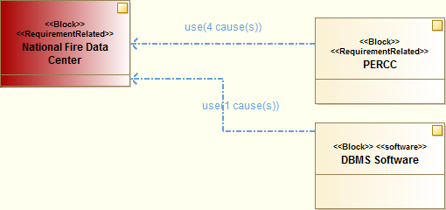

Figure 14 Impact Diagram for "National Fire Data Center"

| Name | Description |
| --- | --- |
| -> : [1..1] PERCC |  |

Table 12 Associations of Block "National Fire Data Center"

| Name | Requires | Provides |
| --- | --- | --- |
| nfdcm |  |  |
| nfdcpw |  |  |

Table 13 Ports of Class "National Fire Data Center"

## Block "Alert Management System"

from Package INCOSE_Challenge.PERCC Structure.Internal Structure

Stereotypes: Block,Allocated

| Name | Description |
| --- | --- |
| -> : [1..1] PERCC |  |

Table 14 Associations of Block "Alert Management System"

| Name | Requires | Provides |
| --- | --- | --- |
| amscm |  |  |
| amspw |  |  |

Table 15 Ports of Class "Alert Management System"

## Block "National Fire Incident Reporting Center"

from Package INCOSE_Challenge.PERCC Structure.Internal Structure

Stereotypes: Block,Allocated

| Name | Description |
| --- | --- |
| -> : [1..1] PERCC |  |

Table 16 Associations of Block "National Fire Incident Reporting Center"

| Name | Requires | Provides |
| --- | --- | --- |
| nfirccm |  |  |
| nfircpw |  |  |

Table 17 Ports of Class "National Fire Incident Reporting Center"

## Block "PERCC Operations Center"

from Package INCOSE_Challenge.PERCC Structure.Internal Structure

Stereotypes: Block,Allocated,RequirementRelated

| Name | Description |
| --- | --- |
| -> : [1..1] PERCC |  |

Table 18 Associations of Block "PERCC Operations Center"

| Name | Requires | Provides |
| --- | --- | --- |
| opcomm |  |  |
| oppw |  |  |

Table 19 Ports of Class "PERCC Operations Center"

## Block "Central Communications/Dispatch Center"

from Package INCOSE_Challenge.PERCC Structure.Internal Structure

Stereotypes: Block,RequirementRelated

| Name | Description |
| --- | --- |
| -> : [1..1] PERCC |  |

Table 20 Associations of Block "Central Communications/Dispatch Center"

| Name | Requires | Provides |
| --- | --- | --- |
| ccmint |  |  |
| ccpw |  |  |
| ccmext | Interface AV Comm | Interface AV Comm |

Table 21 Ports of Class "Central Communications/Dispatch Center"

## Block "Power System"

from Package INCOSE_Challenge.PERCC Structure.Internal Structure

Stereotypes: Block,Allocated

| Name | Description |
| --- | --- |
| -> : [1..1] PERCC |  |

Table 22 Associations of Block "Power System"

| Name | Requires | Provides |
| --- | --- | --- |
| ppw |  |  |
| ppcm |  |  |

Table 23 Ports of Class "Power System"

## Block "Central Database"

from Package INCOSE_Challenge.PERCC Structure.Internal Structure

Stereotypes: Block

| Name | Requires | Provides |
| --- | --- | --- |
| dbc |  |  |

Table 24 Ports of Class "Central Database"

## Block "Database Management System"

from Package INCOSE_Challenge.PERCC Structure.Internal Structure

Stereotypes: Block

| Name | Requires | Provides |
| --- | --- | --- |
| dbmscm |  |  |
| dbmscmext |  |  |

Table 25 Ports of Class "Database Management System"

## Block "DBMS Software"

from Package INCOSE_Challenge.PERCC Structure.Internal Structure

Stereotypes: Block,software

## Block "Wildfire Management System"

from Package INCOSE_Challenge.PERCC Structure.Internal Structure

Stereotypes: Block,Allocated,software

State Machine "PERCC Wildfirefighting Modes"

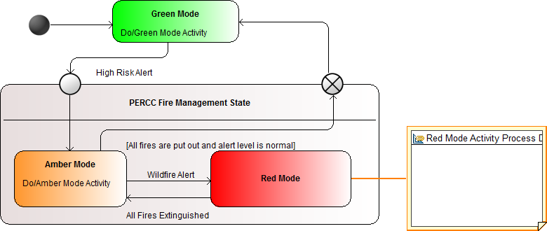

Figure 15 PERCC Wildfirefighting Modes State Machine Diagram

This diagram shows the behavior of the PERCC during wildfire alerts

| Name | Description |
| --- | --- |
| -> : [1..1] PERCC |  |

Table 26 Associations of Block "Wildfire Management System"

## Block "Flood Management System"

from Package INCOSE_Challenge.PERCC Structure.Internal Structure

Stereotypes: Block,Allocated,software

| Name | Description |
| --- | --- |
| -> : [1..1] PERCC |  |

Table 27 Associations of Block "Flood Management System"

## Block "Earthquake Management System"

from Package INCOSE_Challenge.PERCC Structure.Internal Structure

Stereotypes: Block,Allocated,software

| Name | Description |
| --- | --- |
| -> : [1..1] PERCC |  |

Table 28 Associations of Block "Earthquake Management System"

## Block "Nuclear Incidents Management System"

from Package INCOSE_Challenge.PERCC Structure.Internal Structure

Stereotypes: Block,Allocated,software

| Name | Description |
| --- | --- |
| -> : [1..1] PERCC |  |

Table 29 Associations of Block "Nuclear Incidents Management System"

# Package "Parametric"

from Package INCOSE_Challenge.PERCC Structure.Internal Structure

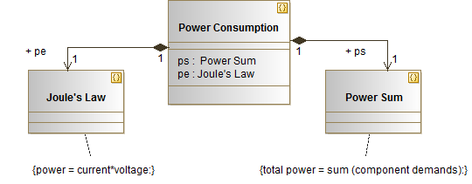

Figure 16 Power Consumation Block Diagram

The Block diagram illustrating relationships between different constraint blocks

| Name | Summary |
| --- | --- |
| Power Consumption |  |
| Joule's Law |  |
| Power Sum |  |

Table 30 Owned Block of Package "Parametric"

## Block "Power Consumption"

from Package INCOSE_Challenge.PERCC Structure.Internal Structure.Parametric

Stereotypes: constraint

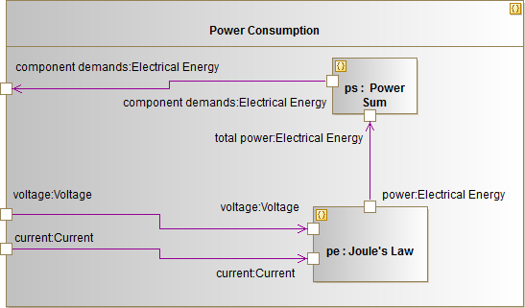

Figure 17 Power Consumption parametric Diagram

The parametric diagram related to the Power Consumption Constraint Block

| Name | Description |
| --- | --- |
| ->pe : [1..1] Joule's Law |  |
| ->ps : [1..1]  Power Sum |  |

Table 31 Associations of Block "Power Consumption"

| Name | Requires | Provides |
| --- | --- | --- |
| component demands |  |  |
| current |  |  |
| voltage |  |  |

Table 32 Ports of Class "Power Consumption"

## Block "Joule's Law"

from Package INCOSE_Challenge.PERCC Structure.Internal Structure.Parametric

Stereotypes: constraint

| Name | Description |
| --- | --- |
| -> : [1..1] Power Consumption |  |

Table 33 Associations of Block "Joule's Law"

| Name | Body | Description |
| --- | --- | --- |
| power = current*voltage |  |  |

Table 34 Constraints of Block "Joule's Law"

| Name | Requires | Provides |
| --- | --- | --- |
| power |  |  |
| voltage |  |  |
| current |  |  |

Table 35 Ports of Class "Joule's Law"

## Block " Power Sum"

from Package INCOSE_Challenge.PERCC Structure.Internal Structure.Parametric

Stereotypes: constraint

| Name | Description |
| --- | --- |
| -> : [1..1] Power Consumption |  |

Table 36 Associations of Block " Power Sum"

| Name | Body | Description |
| --- | --- | --- |
| total power = sum (component demands) |  |  |

Table 37 Constraints of Block " Power Sum"

| Name | Requires | Provides |
| --- | --- | --- |
| total power |  |  |
| component demands |  |  |

Table 38 Ports of Class " Power Sum"

# Package "SI Derived Units Expressed In Base Units"

from Component INCOSE_Challenge.SIDefinitions

| Name | Representing | Value |
| --- | --- | --- |
| Acceleration |  |  |
| AmountOfSubstanceConcentration |  |  |
| Area |  |  |
| CurrentDensity |  |  |
| Luminance |  |  |
| MagneticFieldStrength |  |  |
| MassDensity |  |  |
| SpecificVolume |  |  |
| Velocity |  |  |
| Volume |  |  |
| WaveNumber |  |  |
| AmperePerMeter |  |  |
| AmperePerSquareMeter |  |  |
| CandelaPerSquareMeter |  |  |
| CubicMeter |  |  |
| CubicMeterPerKilogram |  |  |
| KilogramPerCubicMeter |  |  |
| MeterPerSecond |  |  |
| MeterPerSecondSquared |  |  |
| MolePerCubicMeter |  |  |
| ReciprocalMeter |  |  |
| SquareMeter |  |  |

Table 39 Instances of Package "SI Derived Units Expressed In Base Units"

# Package "SI Base Units"

from Component INCOSE_Challenge.SIDefinitions

| Name | Representing | Value |
| --- | --- | --- |
| AmountOfSubstance |  |  |
| ElectricCurrent |  |  |
| Length |  |  |
| LuminousIntensity |  |  |
| Mass |  |  |
| ThermodynamicTemperature |  |  |
| Time |  |  |
| Ampere |  |  |
| Candela |  |  |
| Kelvin |  |  |
| Kilogram |  |  |
| Meter |  |  |
| Mole |  |  |
| Second |  |  |

Table 40 Instances of Package "SI Base Units"

# Package "SI Derived Units With Special Names"

from Component INCOSE_Challenge.SIDefinitions

| Name | Representing | Value |
| --- | --- | --- |
| AbsorbedDose |  |  |
| ActivityOfRadionuclide |  |  |
| Capacitance |  |  |
| CatalyticActivity |  |  |
| CelsiusTemperature |  |  |
| DoseEquivalent |  |  |
| ElectricCharge |  |  |
| ElectricConductance |  |  |
| ElectricPotentialDifference |  |  |
| ElectricResistance |  |  |
| Energy |  |  |
| Force |  |  |
| Frequency |  |  |
| Illuminance |  |  |
| Inductance |  |  |
| LuminousFlux |  |  |
| MagneticFlux |  |  |
| MagneticFluxDensity |  |  |
| PlaneAngle |  |  |
| Power |  |  |
| Pressure |  |  |
| SolidAngle |  |  |
| Bequerel |  |  |
| Coulomb |  |  |
| Degree Celsius |  |  |
| Farad |  |  |
| Gray |  |  |
| Henry |  |  |
| Hertz |  |  |
| Joule |  |  |
| Katal |  |  |
| Lumen |  |  |
| Lux |  |  |
| Newton |  |  |
| Ohm |  |  |
| Pascal |  |  |
| Radian |  |  |
| Siemens |  |  |
| Sievert |  |  |
| Steradian |  |  |
| Tesla |  |  |
| Volt |  |  |
| Watt |  |  |
| Weber |  |  |

Table 41 Instances of Package "SI Derived Units With Special Names"

# Package "Types"

from Package INCOSE_Challenge

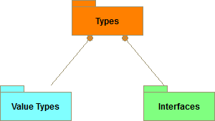

Figure 18 Types

This diagram shows the different types (value types, interfaces) used in the solution

| Name | Summary |
| --- | --- |
| Value Types |  |
| Interfaces |  |

Table 42 Owned Packages of Package "Types"

# Package "Value Types"

from Package INCOSE_Challenge.Types

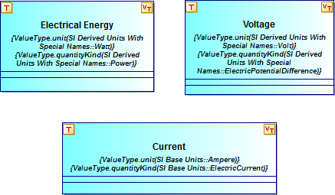

Figure 19 ValueTypes

Here, the "Electrical Energy" user defined valye type is defined, using concepts defined in the Modelio SysML library

| Name | Summary |
| --- | --- |
| Electrical Energy |  |
| Voltage |  |
| Current |  |

Table 43 Owned ValueTypes of Package "Value Types"

## ValueType "Electrical Energy"

from Package INCOSE_Challenge.Types.Value Types

**Stereotypes:** ValueType

## ValueType "Voltage"

from Package INCOSE_Challenge.Types.Value Types

**Stereotypes:** ValueType

## ValueType "Current"

from Package INCOSE_Challenge.Types.Value Types

**Stereotypes:** ValueType

# Package "Interfaces"

from Package INCOSE_Challenge.Types

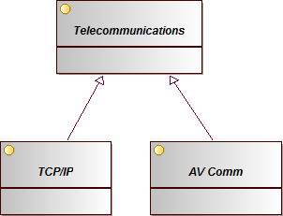

Figure 20 Interfaces

This diagram shows the different interfaces used for communication

| Name | Summary |
| --- | --- |
| TCP/IP |  |
| AV Comm |  |
| Telecommunications |  |

Table 44 Owned Interfaces of Package "Interfaces"

## Interface "TCP/IP"

from Package INCOSE_Challenge.Types.Interfaces

Inherits from: Telecommunications

## Interface "AV Comm"

from Package INCOSE_Challenge.Types.Interfaces

Inherits from: Telecommunications

## Interface "Telecommunications"

from Package INCOSE_Challenge.Types.Interfaces

# Package "INCOSE Challenge Solution"

from Package INCOSE_Challenge

Stereotypes: Document Folder